CS 3365 - Homework #4

Luis Rausseo

R11478074

1) Define the operation (method) names of all classes whose objects participate in the communication diagrams (Figs. 1, 2, 3, 4, 5 and 6) for Check-out Customer use case. The operations should be defined by considering message communication between objects in the communication diagrams. Each operation needs to be defined along with incoming and/or outgoing parameters (10 points)

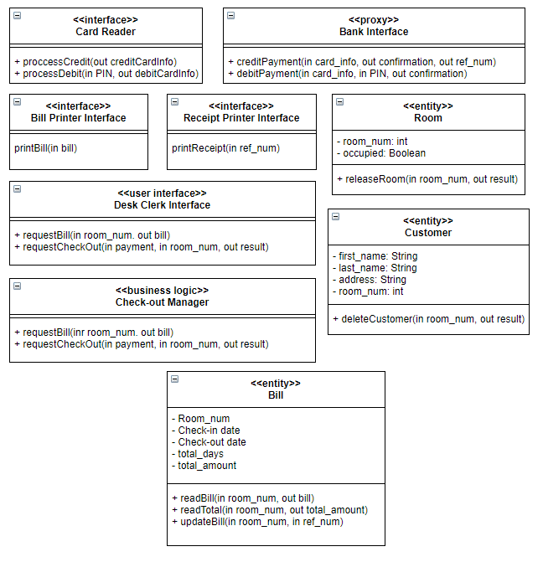

Specify the logic of operations for Check-Out Manager business logic class, which are used to handle the approved credit card case (Fig. 1). The logic of the operations should be specified using the operations of objects (defined in above (1)) in the communication diagram for approval credit card case (Fig. 1). (10 points)

requestBill(in room_num, out bill) {

bill = readBill(room_num)

return bill;

}

requestCheckOut(in payment, in room_num, out result){

if (payment == "Credit") {

creditCard = processCredit()

total = readTotal(room_num)

{confirmation, ref_num} = creditPayment(creditCard)

if (confirmation != "Denied") {

printReceipt(ref_num)

updateBill(room_num, ref_num)

roomReleased = releaseRoom(room_num)

if (roomReleased == True) {

customerDeleted = deleteCustomer(room_num)

if (customerDeleted == True) {

bill = readBill(room_num)

printBill(bill)

return True

}

}

}

else {

return False

}

}

}